**Appendix**

**PCA**

* Figure 1. The correlation matrix heatmap shows the correlation between each principal component

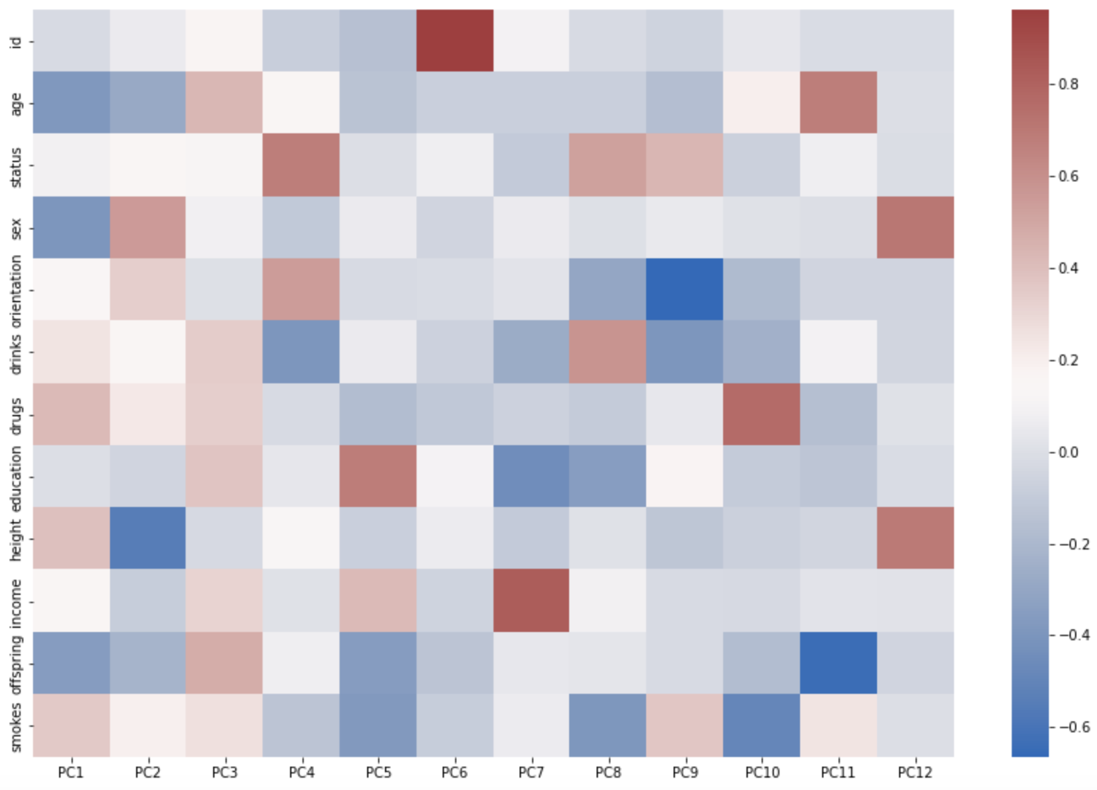

**H-Clustering**

* Figure 2. The dendrogram of four different linkage methods.

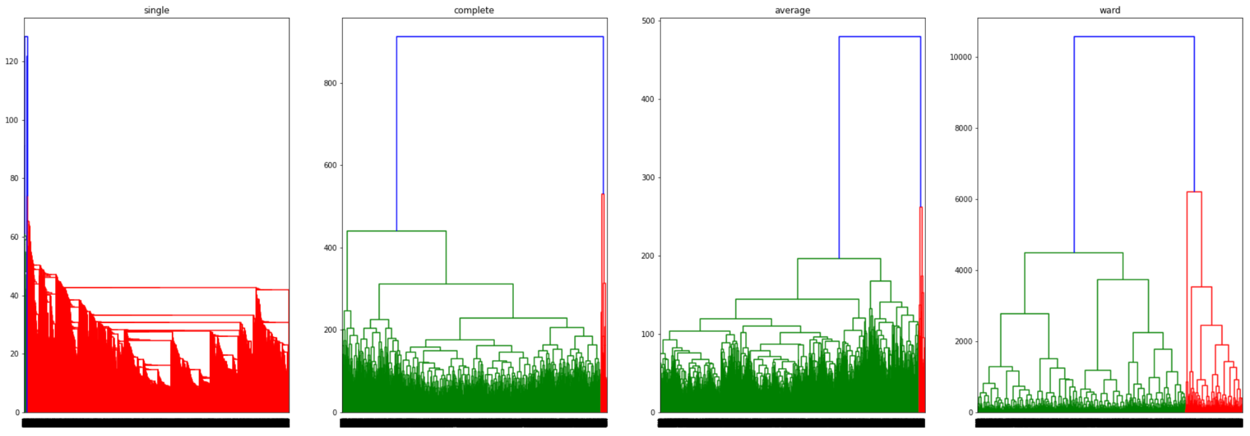

* Figure 3. The dendrogram for ward linkage method.

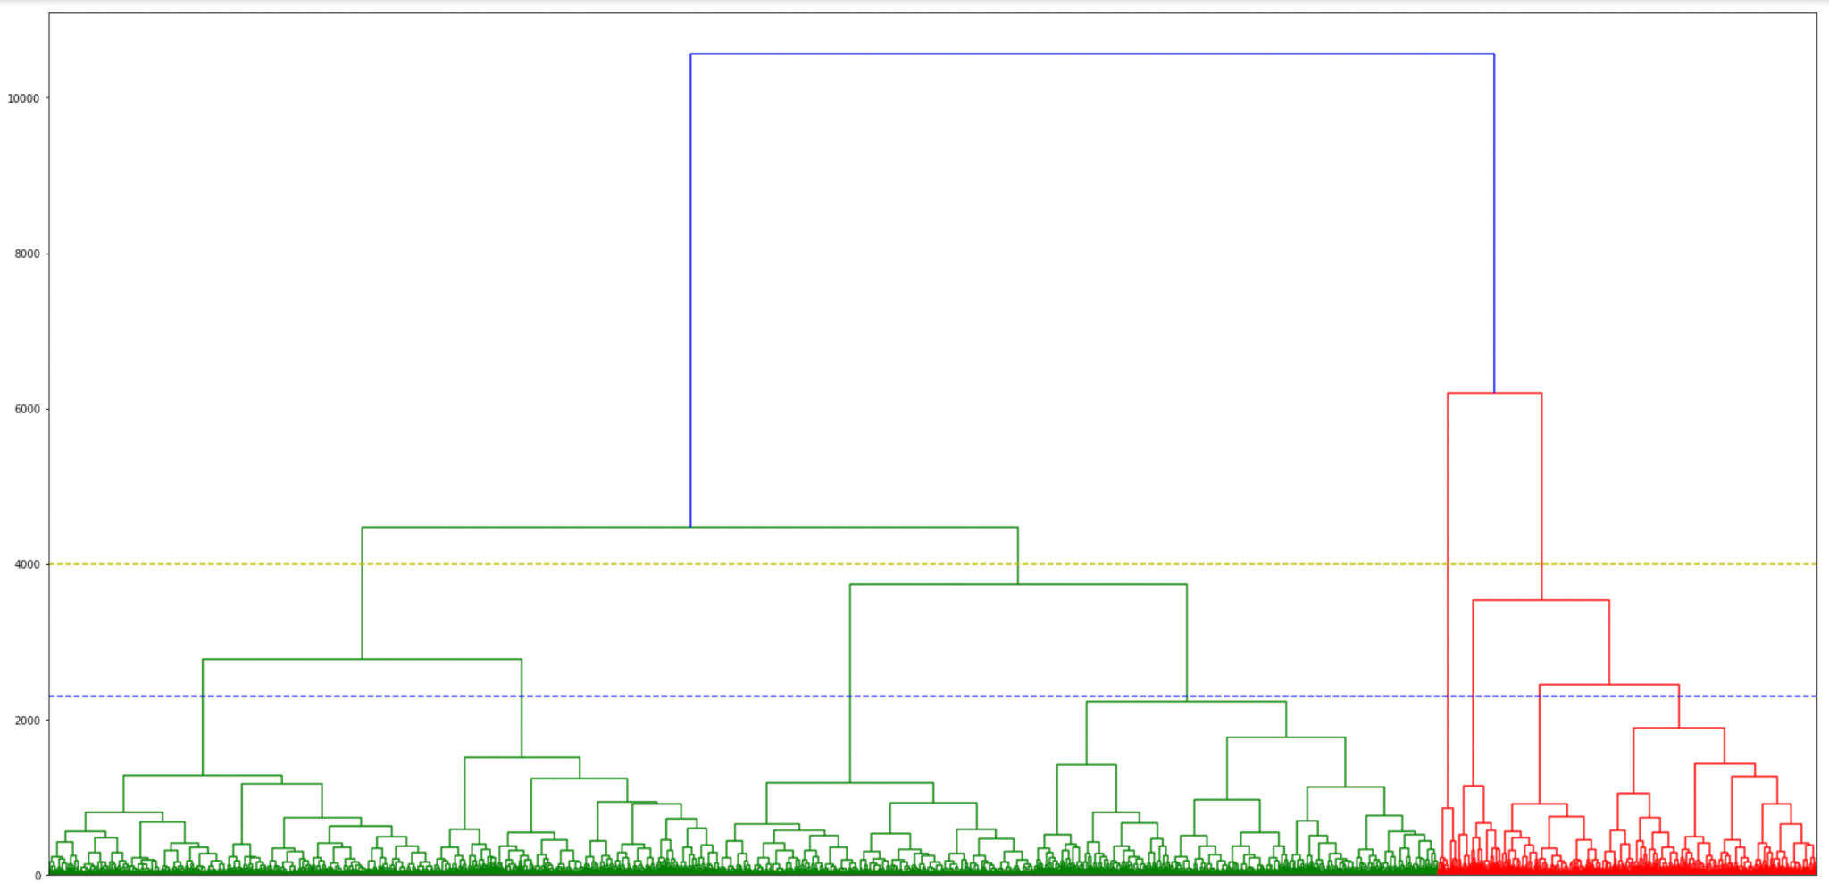

* Figure 4. The silhouette score plots for 5 clusters and 8 clusters.

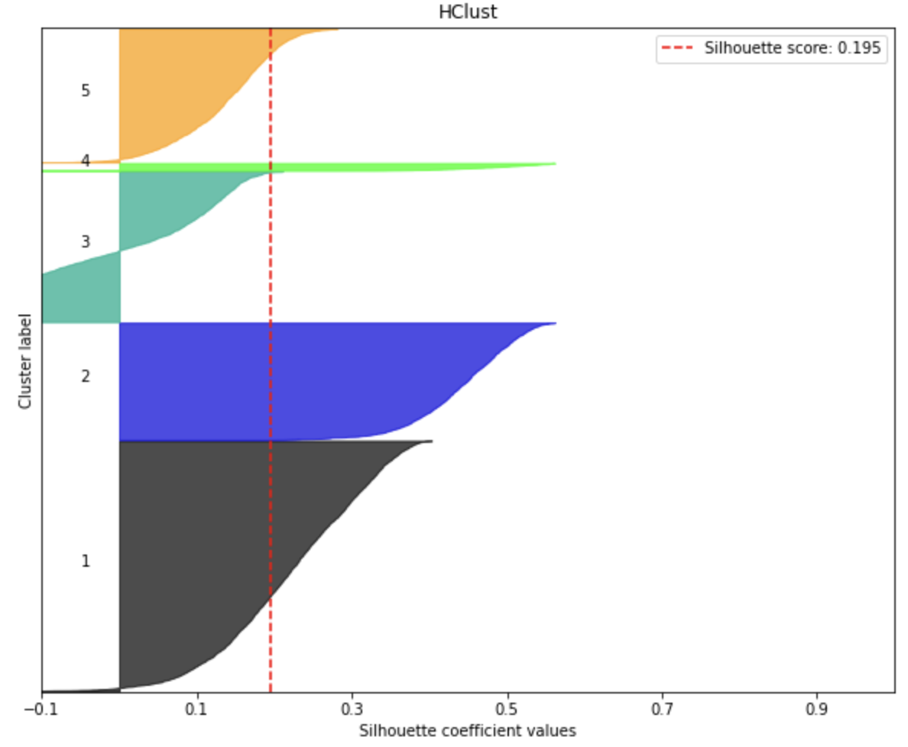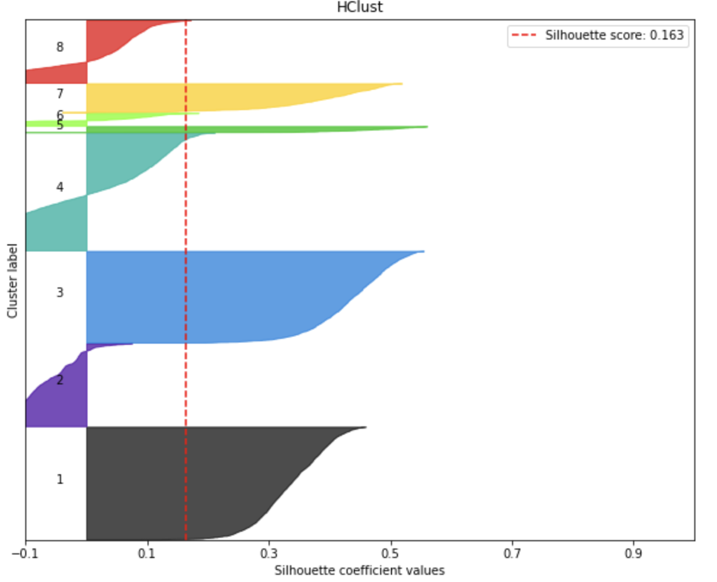

**K-Means Clustering**

* Figure 5. The inertia plot and silhouette Score for choosing an optimal K.

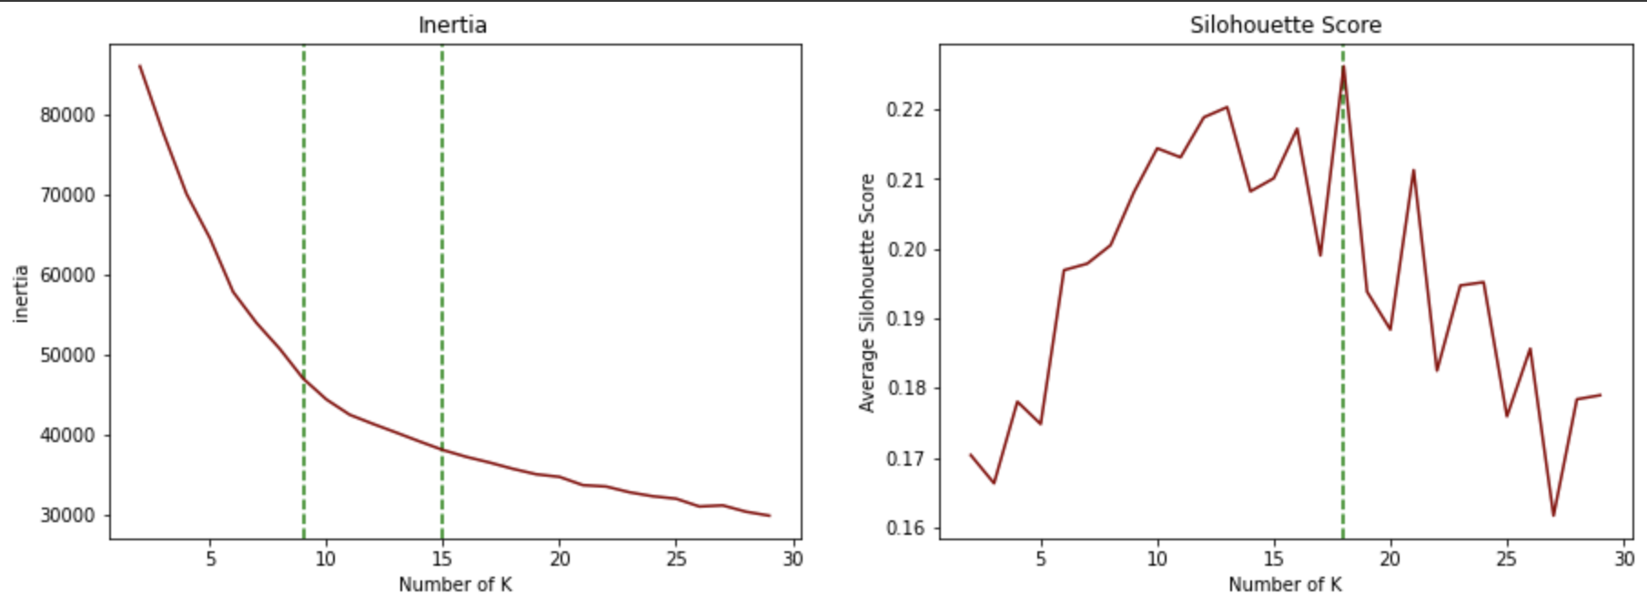

* Figure 6. The silhouette score plot for clusters of 16.

. 